PT5300 Front panel modifications for LCD MC240005AA6W9-BNMLW.

1. Connecting the backlight.
When using the LCD display MC24005AA6W9-BNMLW the backlight must be connected to the keyboard as shown in figure 1 and 2.

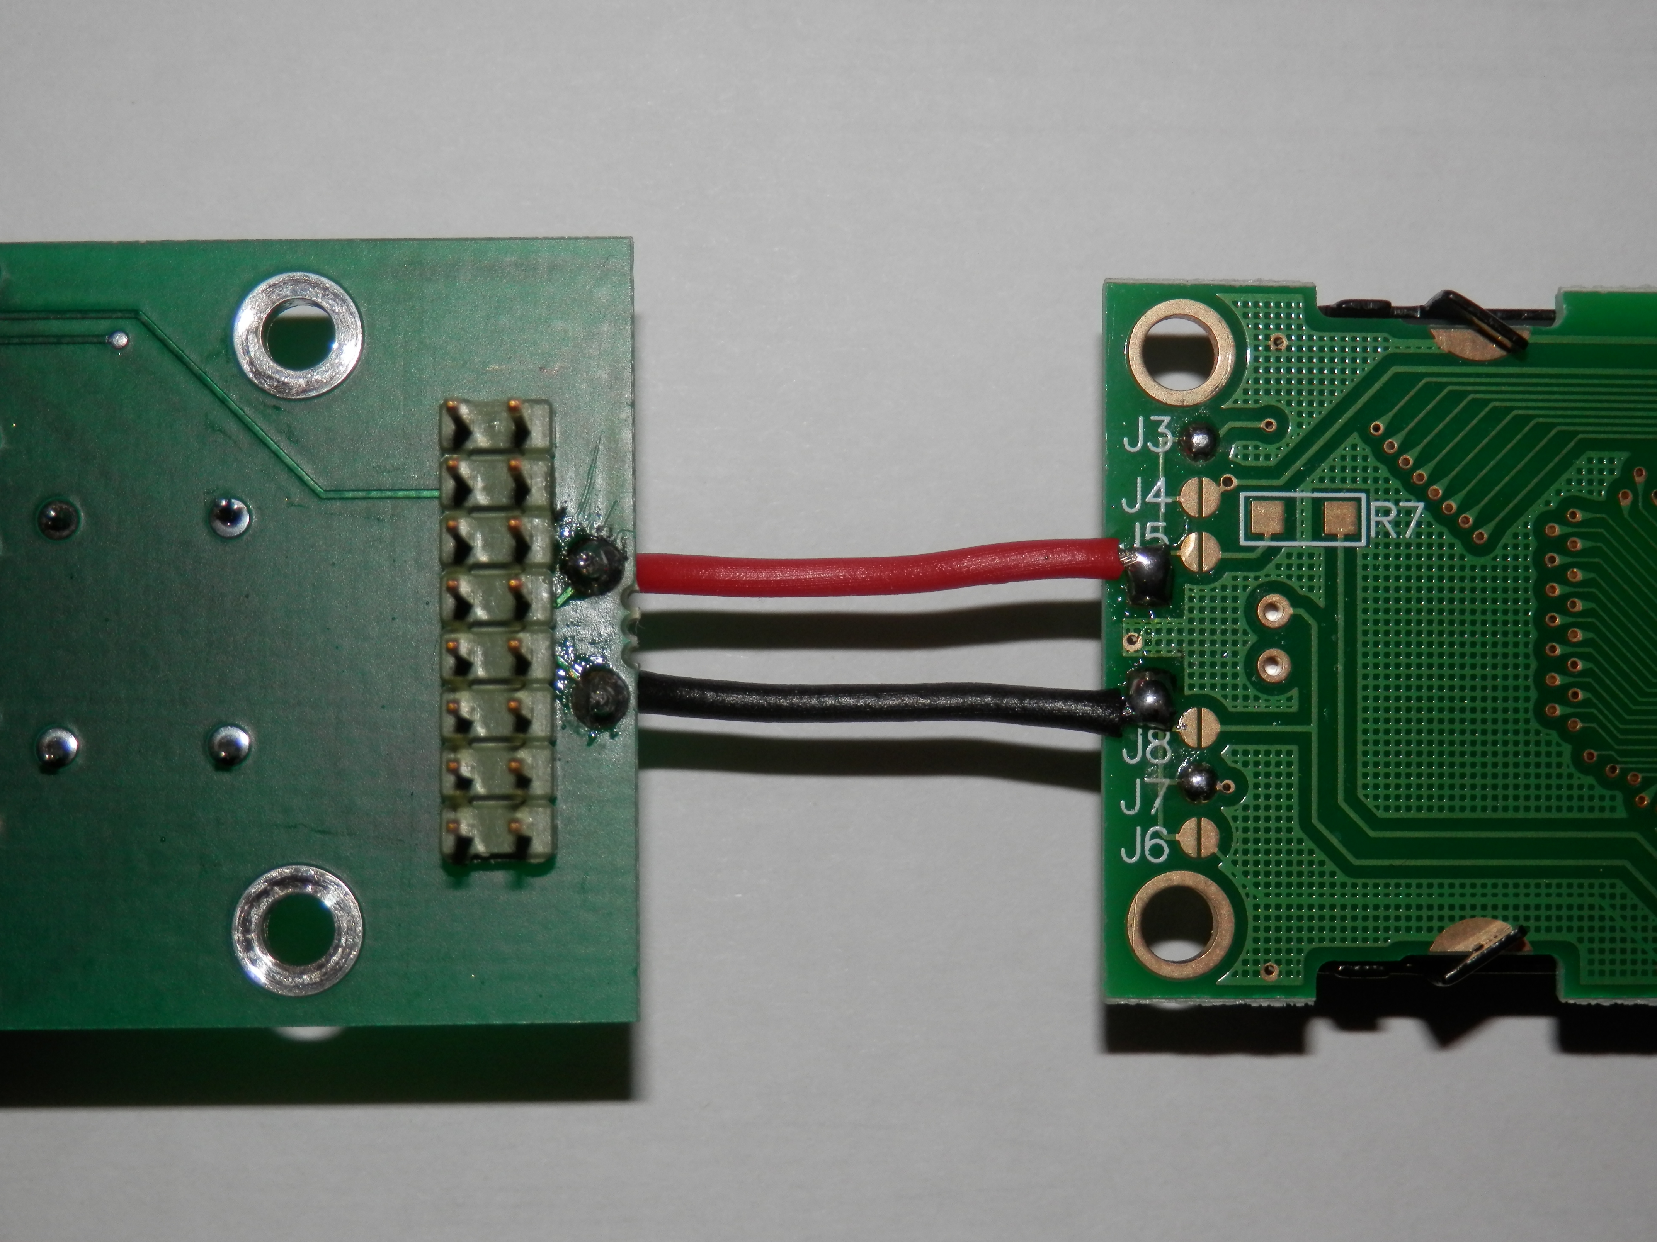 | 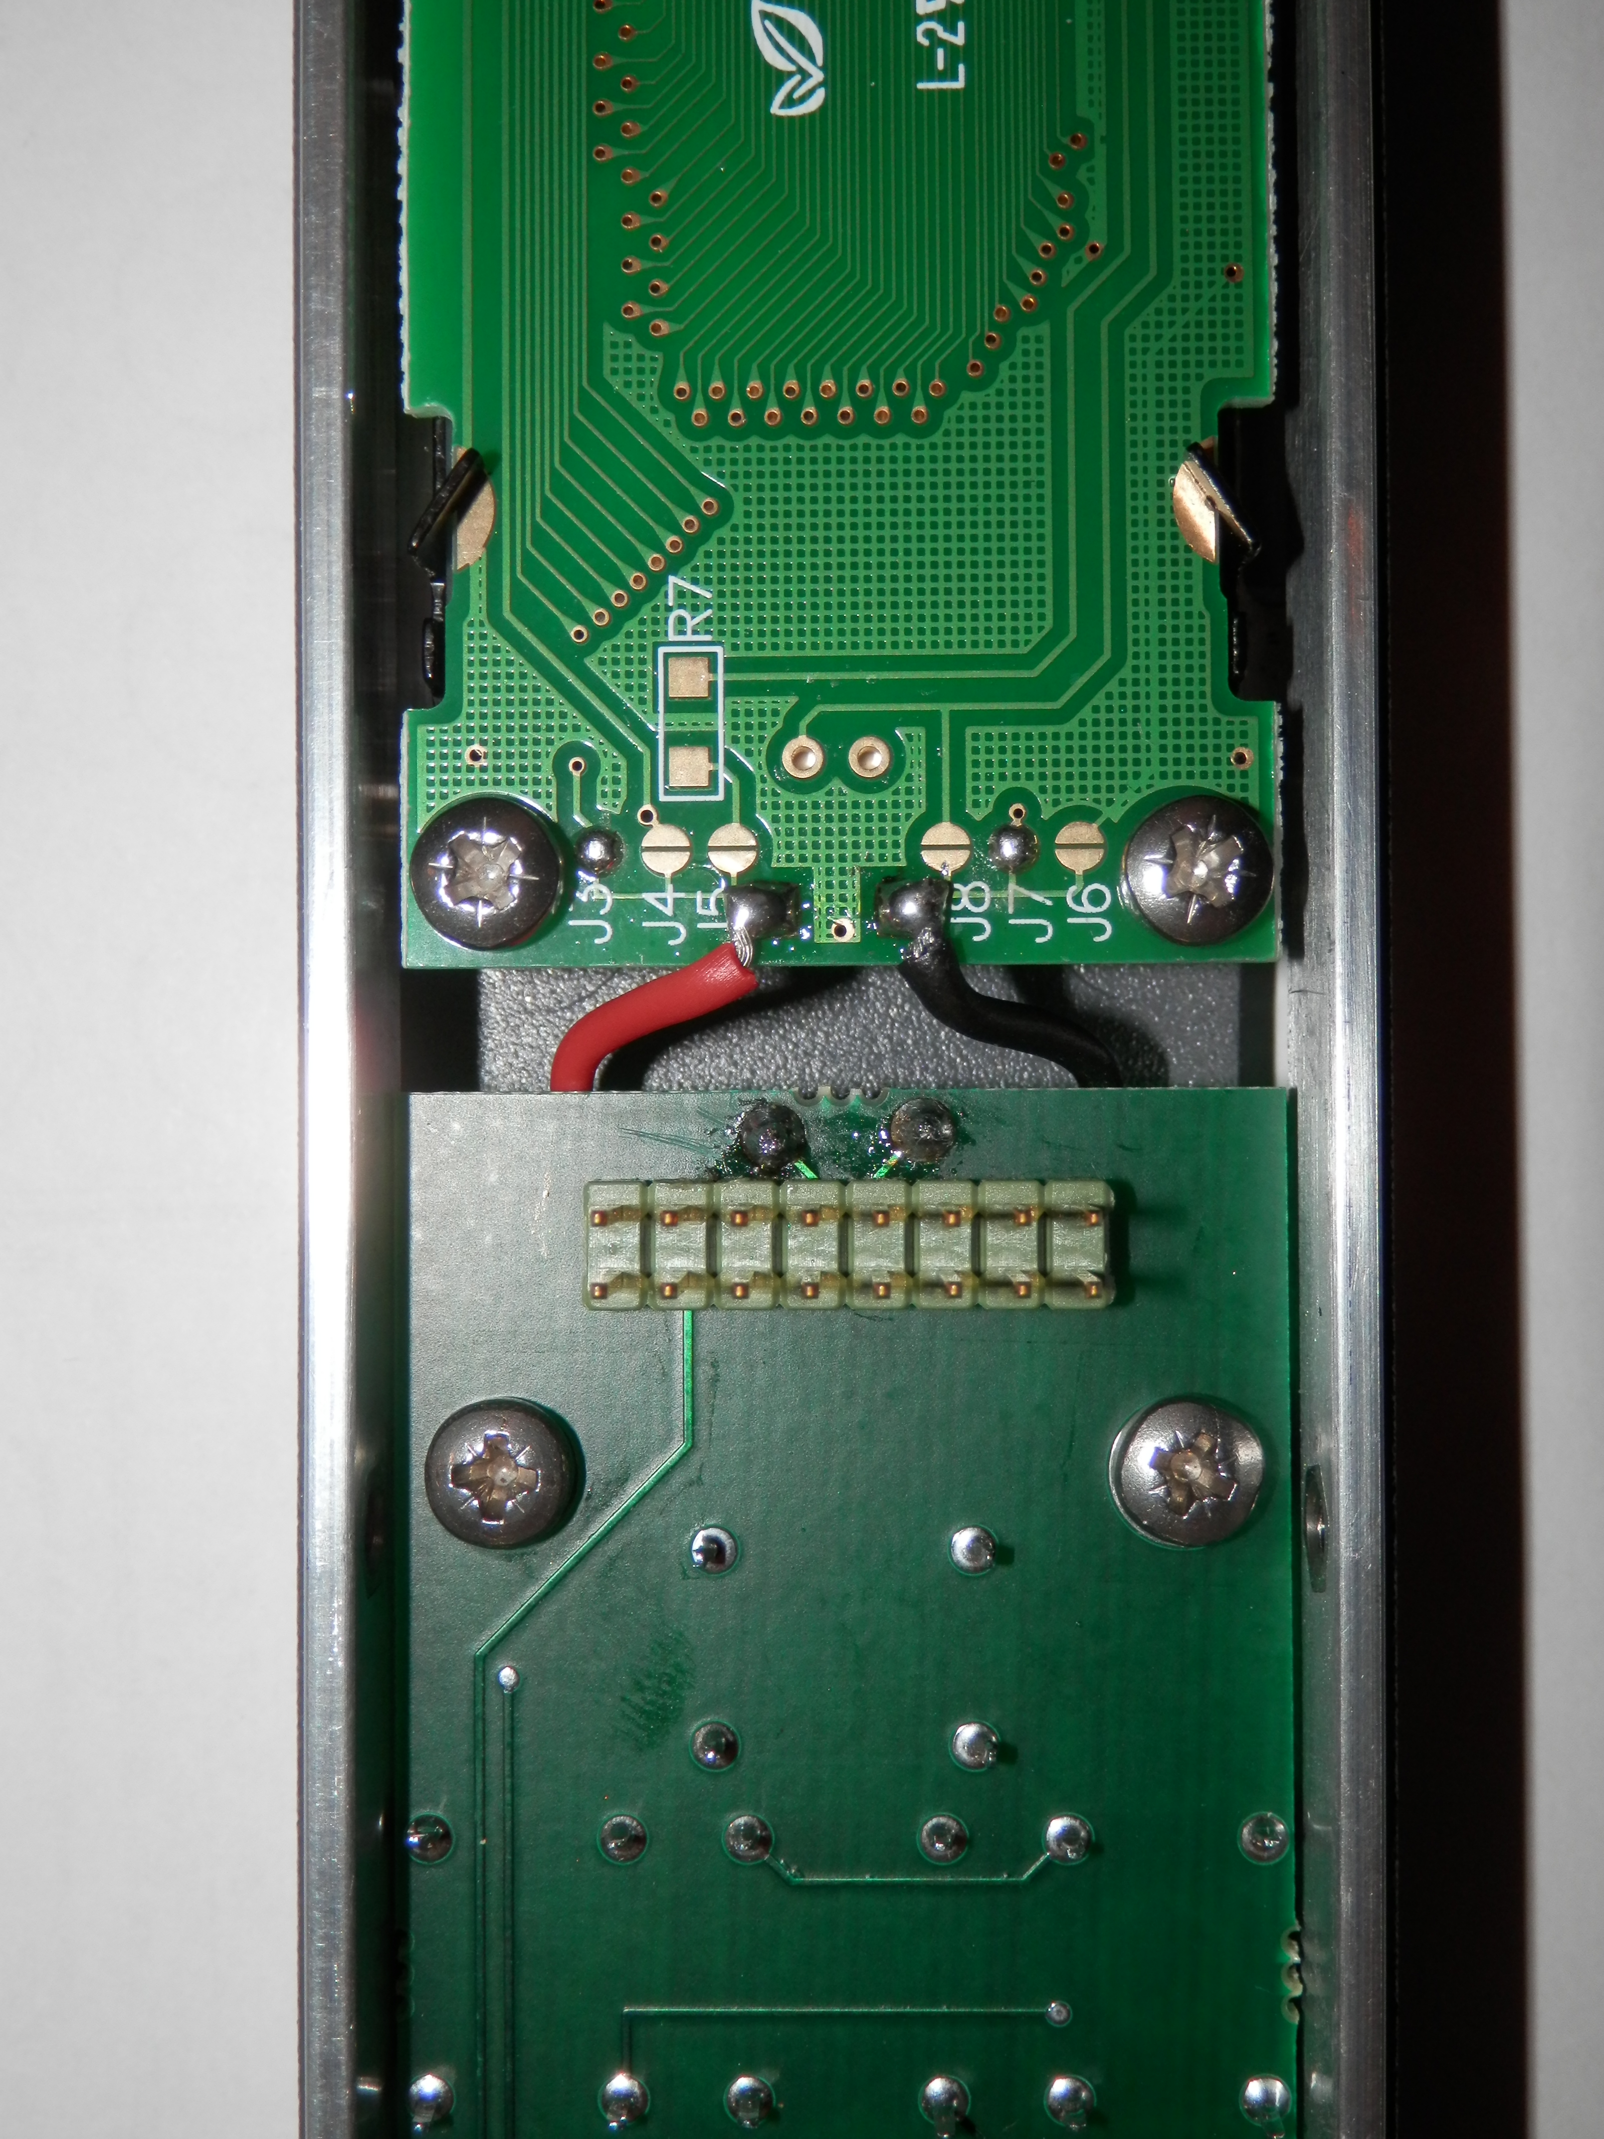
Figure 1. | Figure 2.

Resistor R407 on the PT5300 main board must be changed from 3R9 to 150R 1W as shown in figure 3.
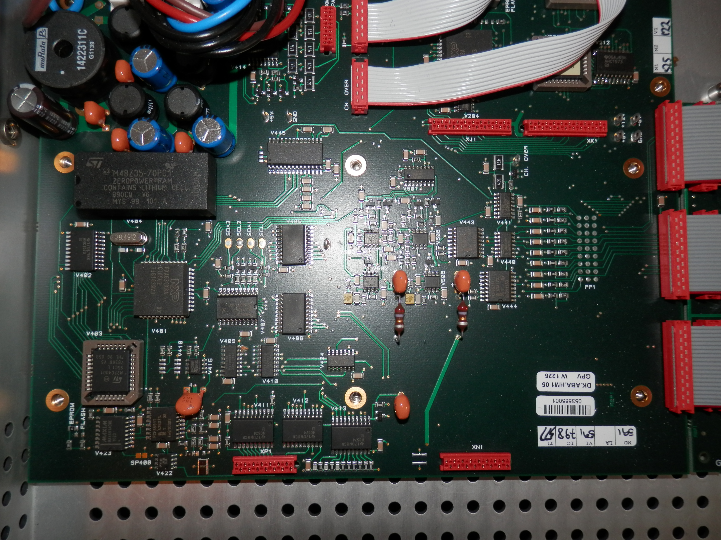
R407
150R
Figure 3.

2. Mounting the display.
M3 x 10 mm. pan head screws are used are used when mounting the display.
A spacer with a length of 3.5 mm. is inserted between the display and the front panel as shown in figure 4.
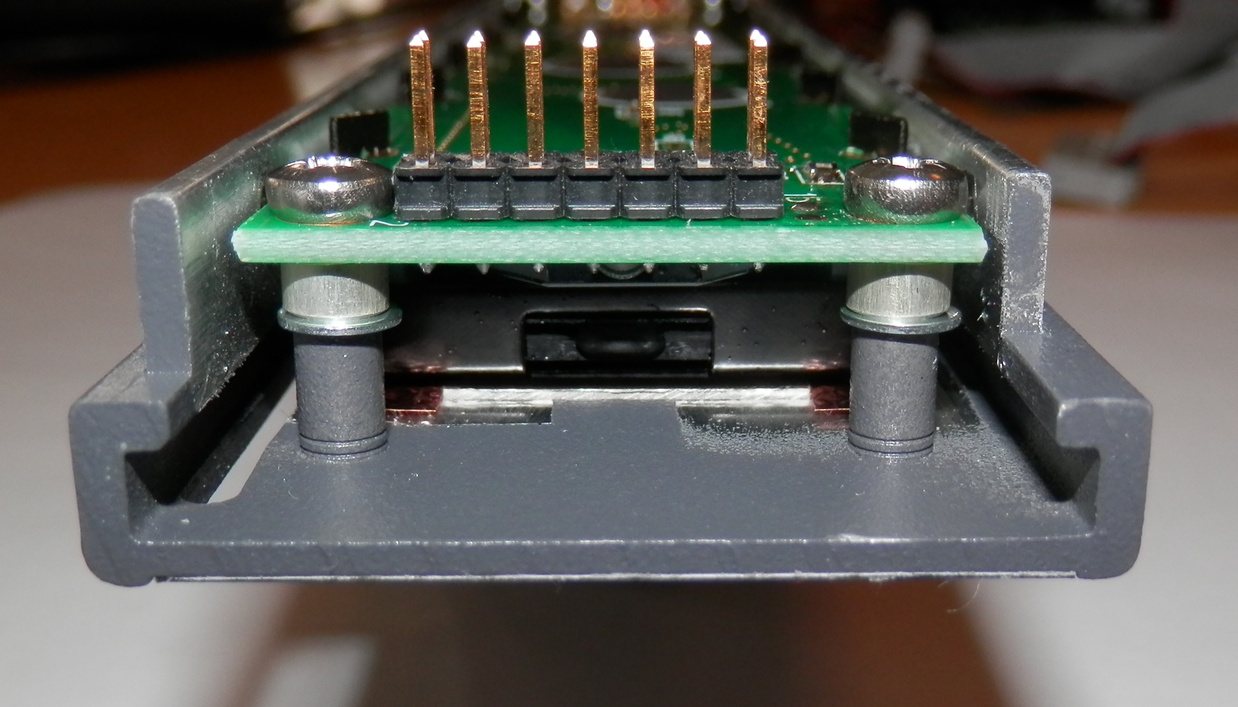
Figure 4.

When mounting the front foil please make sure that revision 5 is used, otherwise the black frame on the LCD will be visible in the right side of the window. Revision 5 has a smaller cutout for the LCD which is 151 x 14,5 mm.

